Modern United States History Units Outline
2024-2025
Unit 2 Info
Learning Targets: | - Learning Target 2A: Evaluate the impact of efforts to reform US social, political, and economic structures.  - Learning Target 2B: Evaluate how the US government has fostered economic opportunity throughout the 20th century.
Assessment(s) for Evidence | 2A – PowerPoint Presentation  2B- TBD
Resources/Links | 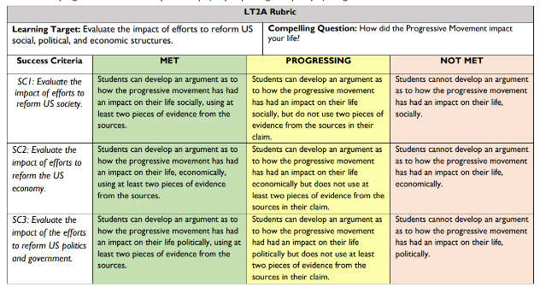  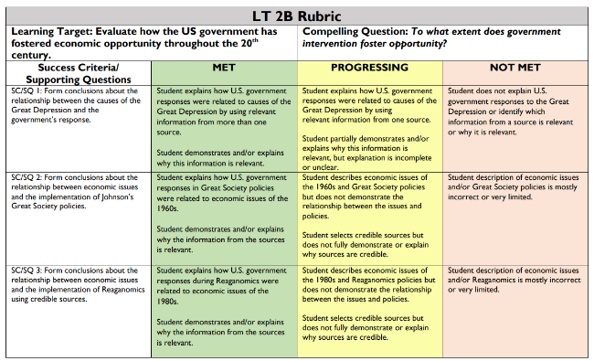

Unit Info
Learning Targets: | - Learning Target 1A: Evaluate the impact of US expansionism and resource extraction.  - Learning Target 1B: Assess the effects of industrialists on U.S. society.  - Learning Target 1C: Form a conclusion about how imperialism changed the role of the US.
Assessment(s) for Evidence | - 1A- Summative assessment (Graphic Organizer)  - 1B- Summative assessment (CER- Claim, Evidence, Reasoning)  - 1C- Summative assessment (Essay or Slideshow Essay)
Resources/Links | 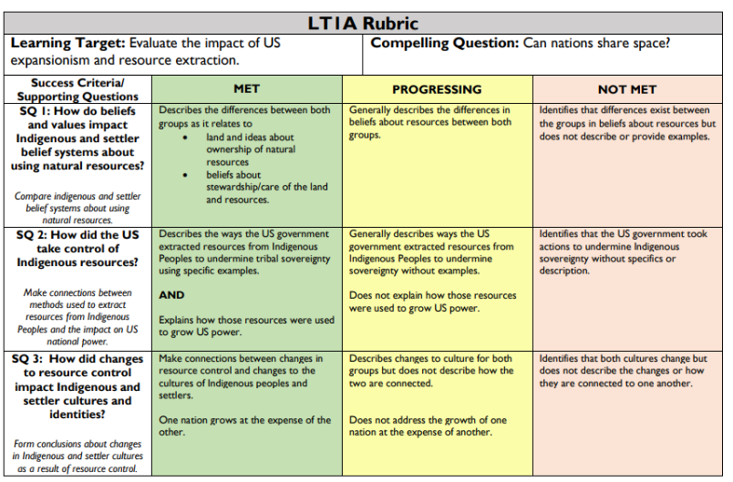  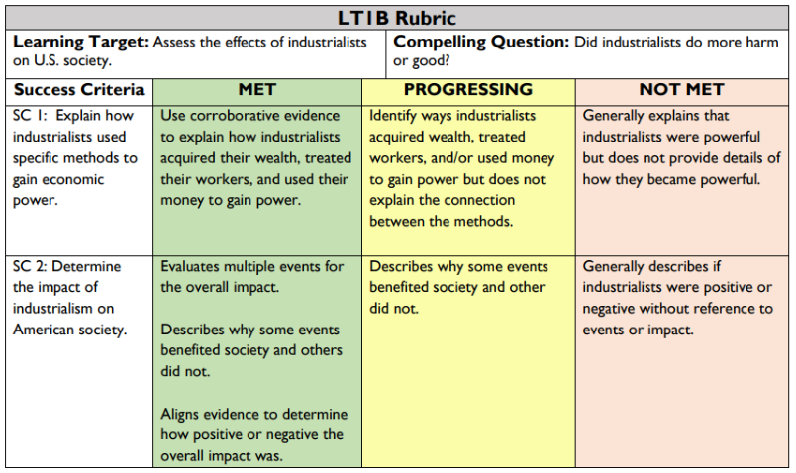  LT1C Rubric  