Algebra I Unit Outline
2024-2025
Unit Info | Topic 3 Inequalities
Learning Targets: | 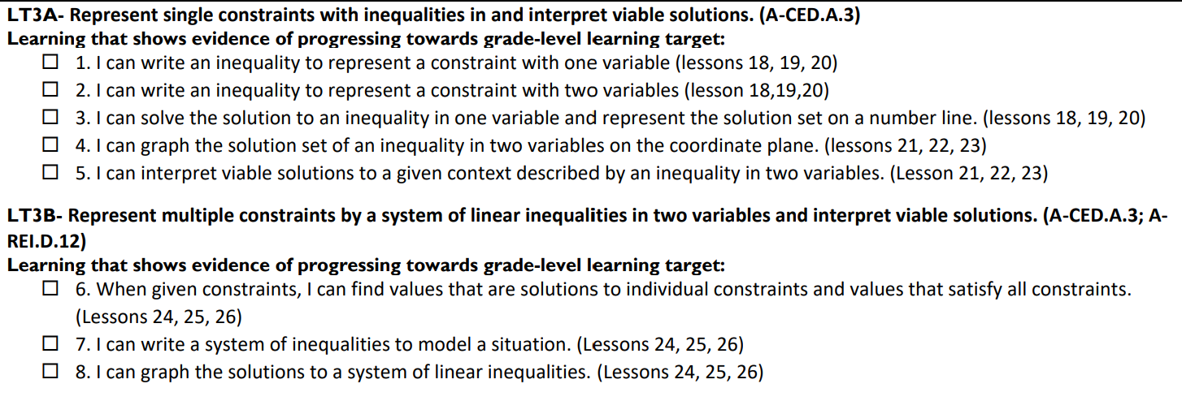
Assessment(s) for Evidence | Multiple tests and quizzes throughout unit that must be completed with a teacher.
Resources/Links | https://www.khanacademy.org/math/algebra-1-illustrative-math/x6418b49dfbc9d0c9:inequalities

 | Topic 2 Equations
Learning Targets: | 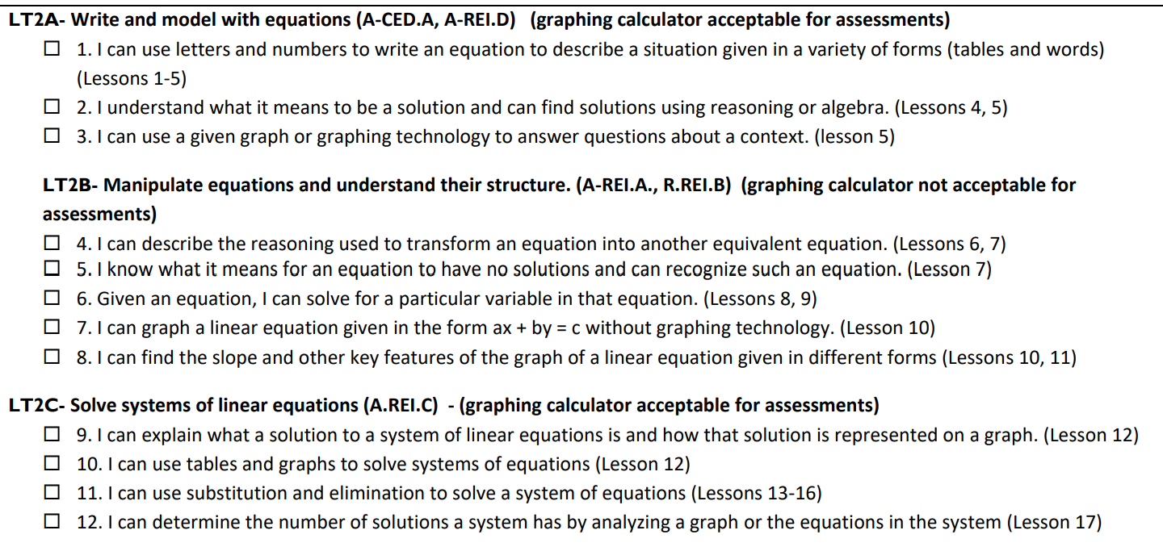
Assessment(s) for Evidence | Multiple tests and quizzes throughout unit that must be completed with a teacher.
Resources/Links | 2A and 2B: https://www.khanacademy.org/math/algebra-1-illustrative-math/x6418b49dfbc9d0c9:linear-equations  2C: https://www.khanacademy.org/math/algebra-1-illustrative-math/x6418b49dfbc9d0c9:systems-linear-equations

