Modern United States History Units Outline
2024-2025
Unit Info
Learning Targets: | - Learning Target 1A: Evaluate the impact of US expansionism and resource extraction.  - Learning Target 1B: Assess the effects of industrialists on U.S. society.  - Learning Target 1C: Form a conclusion about how imperialism changed the role of the US.
Assessment(s) for Evidence | - Short Answer  - Essay
Resources/Links | 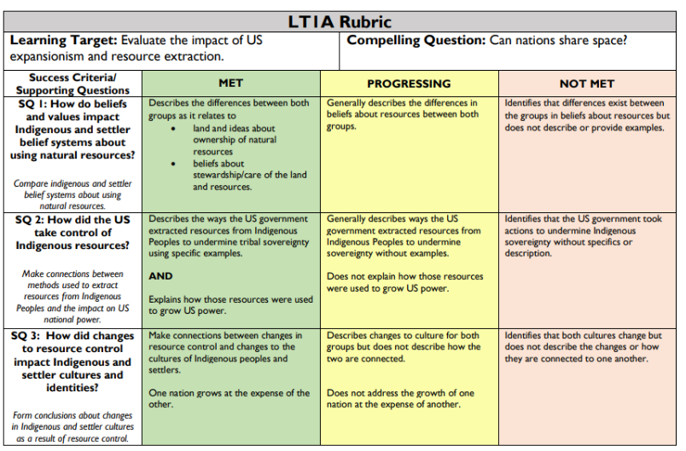  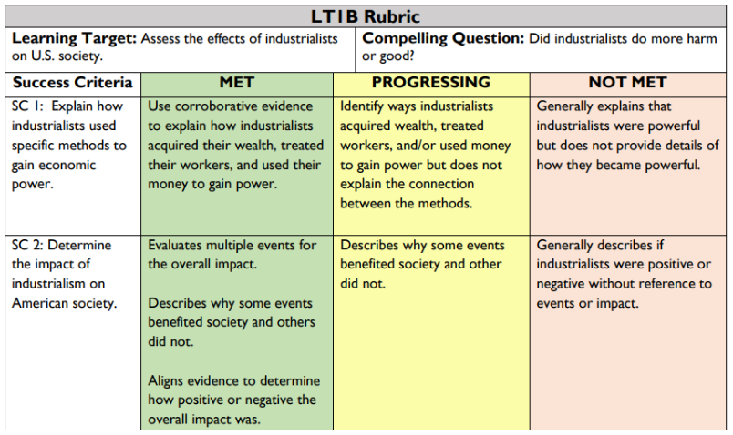  LT1C Rubric  