SkyDrive is replacing the previously used H drive for all DMPS students. SkyDrive is a cloud based storage vault with 7gb of storage for any type of file. Files you save to a computer at home, school, or library can be uploaded to SkyDrive. Think of it as your own portable flash drive accessible where ever you go!

Below are directions to log into your SkyDrive account.

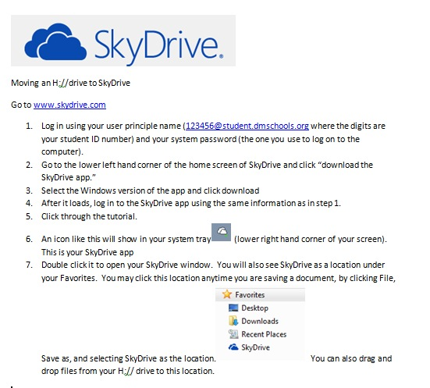

\*You do not need to install the App on every computer you log into. For instance, if you were in the library or on classroom laptop, you could just save to the desktop. Log in to your SkyDrive account and click the Upload button.

