Order Form
Rider Root Beer

First Name Last Name Phone Number

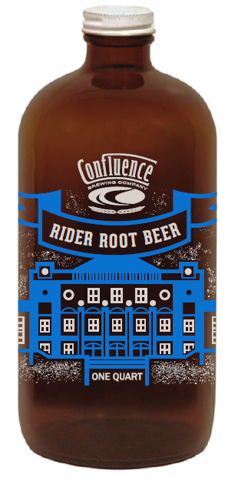
Number of ½ Growler Bottles Email Address
*($10 each, 32oz bottle)

PLEASE COMPLETE AND DELIVER TO: Sherida Kuehler – TRHS Bookkeeper
Sherida.kuehler@dmschools.org

PAYMENT OPTIONS (bring payment into TRHS with order form):

- Cash
- Checks - make checks payable to Roosevelt High School
- Credit Card - please bring credit card into TRHS with order form

DELIVERY DATE: Bottles will be ready for pick-up on Friday, May 20th.
Pick-up location - TRHS Main Office
ORDER DEADLINE = Wednesday, May 18, 2016
OFFICE USE ONLY:
Amount Paid: ___________ Bottles: ________
Cash: _________ Received By: _________________________
Check: _________ # ____________________________ Date: ________________
CC: _________ Last 4-digits ___ ___ ___ ___

*All proceeds from Rider Root Beer sales will go directly to the Art and Science Departments
at Theodore Roosevelt High School – Des Moines, IA – 515.242.7272
Please have customer sign and date at time of pick-up to verify receipt of order.

Print Name: ____________________________________ Signature: ____________________________________

Date of pick-up: _________________________ # of bottles received: ______________

